**Assignment 15.5**

**Problem Statement:**

Build and Deploy Hadoop word count program using SBT

Note: You can use any program of your choice.

**Solution:**

**SBT build:**

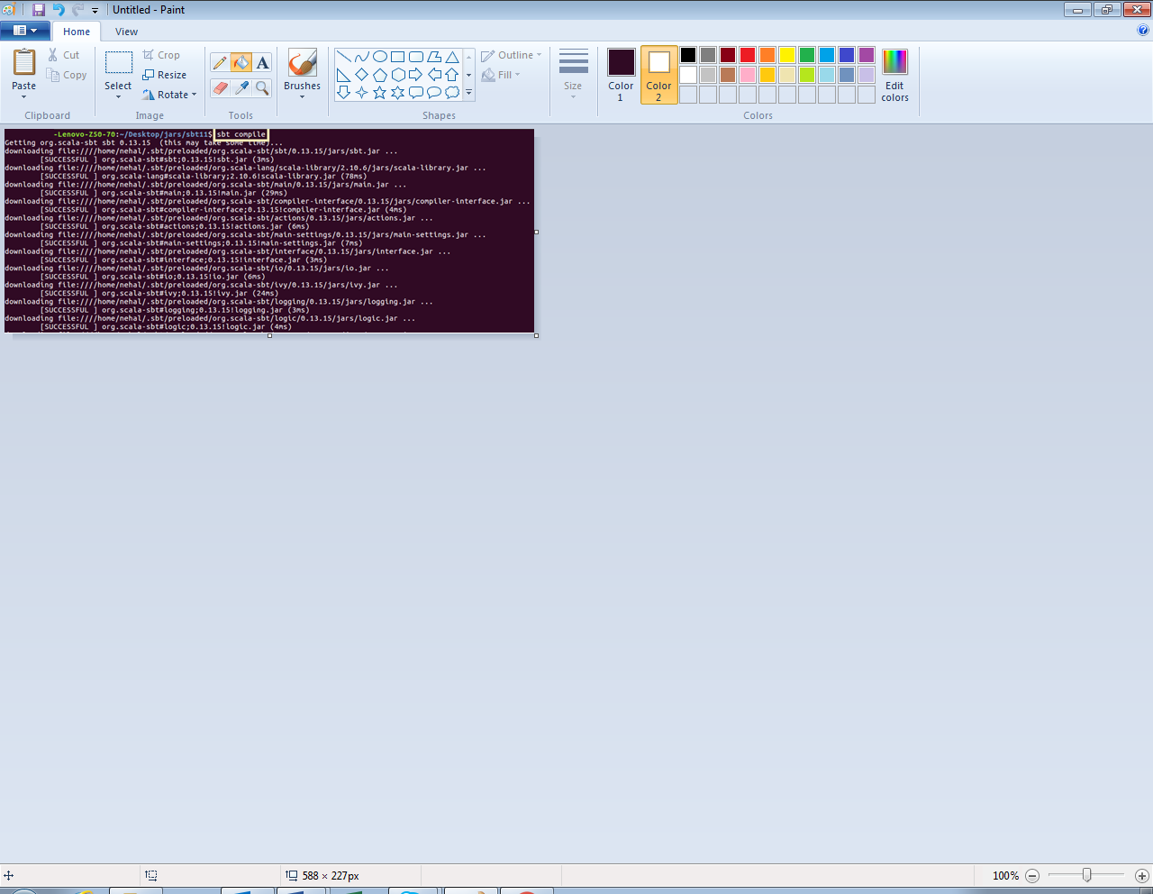



**SBT build file:**

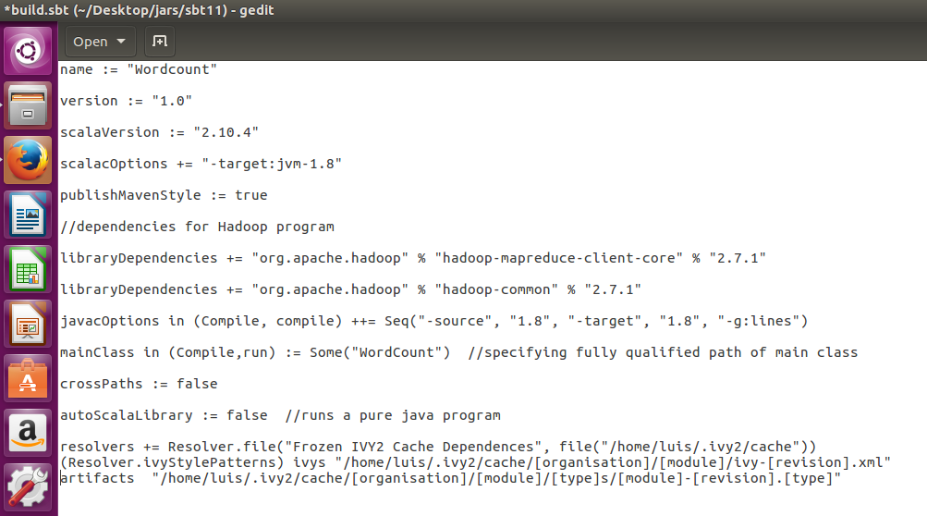

**Word count program:**

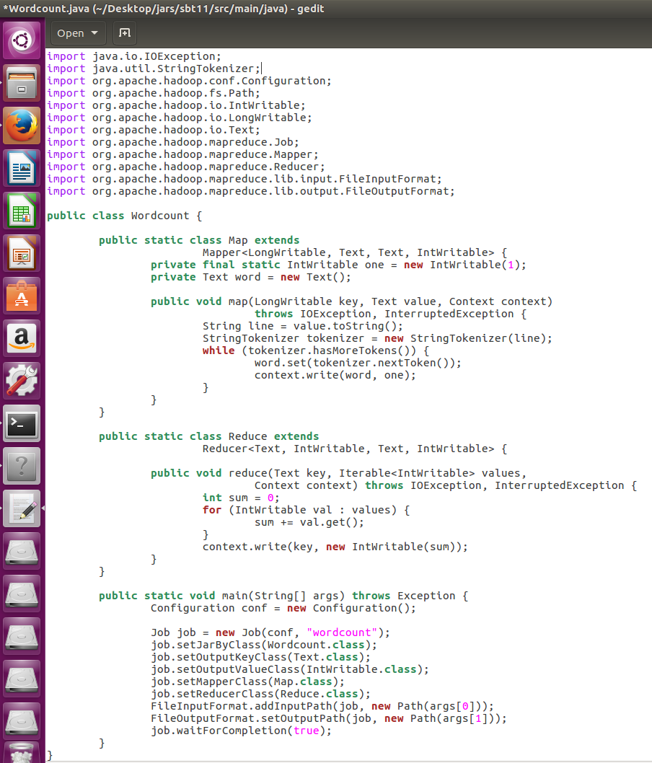

**Running SBT project (jar file):**

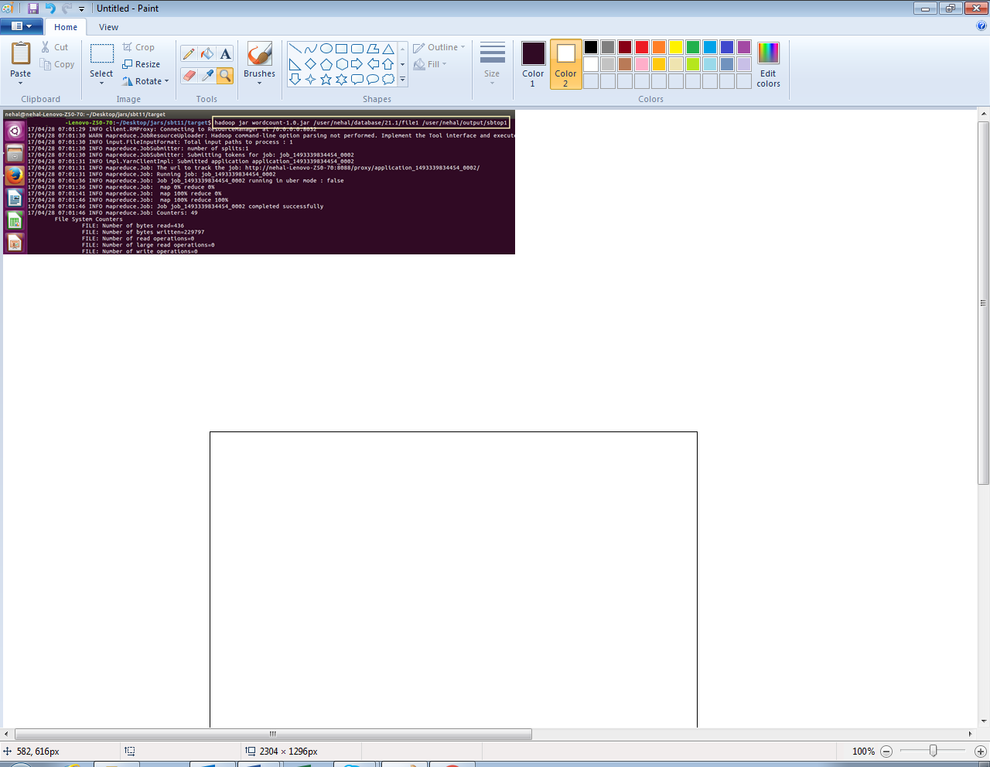

**Output:**

